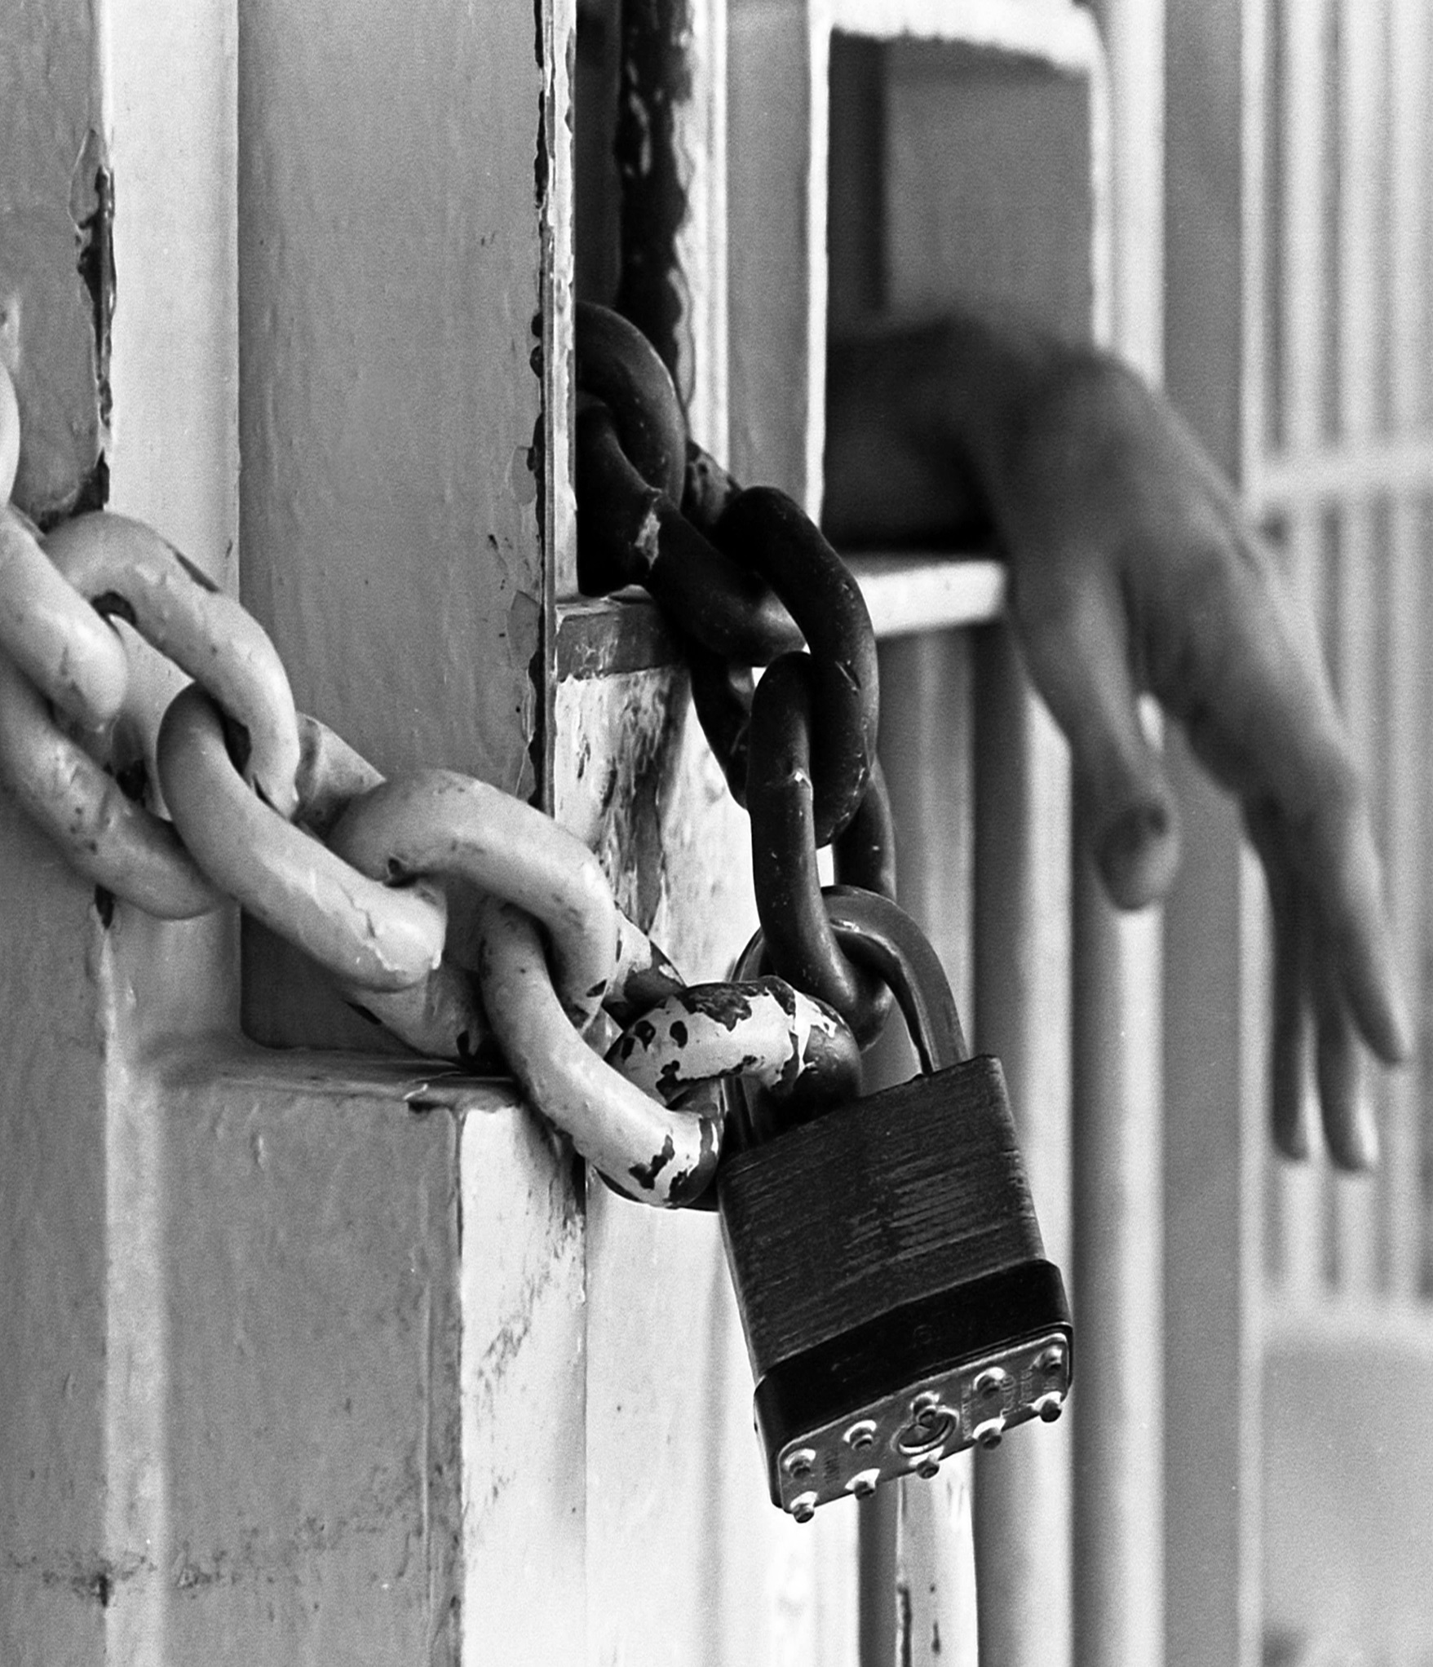
Exposing the Corruption behind Private Prison Corporations

Lock up Quotas

Table of Contents

Table of Contents……………………………………………………………….1-2

Introduction……………………………………………………………………….3-4

Early History……………………………………………………………………….5-6

Private Prisons: Incarceration for Profit……………………………..6-7

Counter Argument…………………………………………………….………….7

The Theory of Privatization……………………………………………….7-10

The Current Prison State…………………………………………………..…11

Cause for Increase in Prison Population………………………….11-12

The Birth of an Industry……………………………………………….…12-13

“Dramatic Expansion”…………………………………………….….….13-19

Company Specifics…………………………………………………………19-20

Investors……………………………………………………………………….20-21

Immigration and Federal Detention………………………………22-25

Guaranteed Profits……………………………………………………….25-26

Additional Profit and Slave Labor………………………………….27-28

Ramifications of the Prison Industrial Complex…………….28-30

Abuse and Corruption…………………………………………….……30-33

Conclusion……………………………………………………………………34

Suggestions to Problem……………………………………………….36-37

Works Cited…………………………………………………………………38-42

Photo Index……………………………………………………………….…42

Michael Peterson, AnnaMae Bringard, Cody Steward, Jeff Wilson, Natasha Howard
Nov 3, 2013
Exposing Corruption behind Private Prison Corporation
Mary-Jayne Davis

Introduction

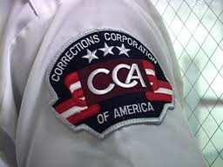
The 1960’s were a time when the United States of America began to expand the power of law enforcement agencies throughout the country. With this, the severity of punishments for crimes was dramatically increased leading Americans to a “prison boom” by the 1970’s (The Prison Boom Produces Prison Privatization). Prisons began to overcrowd far more quickly than prisons were being built, due to prison construction budgets not being sufficient. All of this led to the forming of Corrections Corporation of America in the mid 1980’s (CCA).

After the American Revolution, the United States weren’t unable to ship back the large amounts of colonists that were left on our land, and so began prison privatization. San Quentin was the very first for-profit prison in the United States back in 1852 (Private Jails in the United States). At this time, the leasing out of prisoners for labor was the norm in the United States, following the Emancipation of African Americans. In the South it became known as the “Convict Lease System.” Prisons turned into a main source of cheap and easily controllable labor. This leasing system was very similar to slavery and history shows that these leased prisoners typically experienced worse treatment then slaves due to contractors were guaranteed a certain number of prison laborers, giving them no reason not to work them to death.
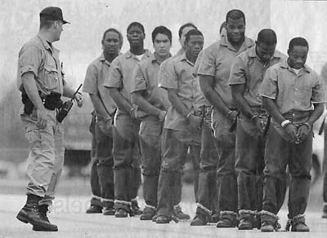
Of the corruption and scandals found in the Convict Leasing System, it became a target of Progressive Era reforms (Grassroots Leadership 12). Prisons were forced to abandon the leasing system and instead, make any work by prisoners done for the government, eliminating private sector involvement. This was a huge step for privately owned prisons but it did not eliminate the mistreatment of prisoners being that roadside chain gangs became known for its brutality. Finally being banned in the early 20th century, we thought we saw the end of prison privatization for good. This was true until Corrections Corporation of America emerged in 1984.

Corrections Corporation of America is a for-profit organization whose plan is essentially to use its own capital to build a new prison owned by them, and rent out its space to a state. With this, occupancy rate requirements are made, and when these quotas aren’t met, the state (meaning the taxpayers) is forced to pay these penalties (Public Interest 3). All in all, this issue is quite controversial being that privately owned prisons were outlawed in the beginning of the 20th century.

Early History

Corrections Corporation of America (CCA) was founded in 1983 by Tom Beasley, Doctor Robert Crants, and T. Don Hutto. It was presented to the government as an exciting new entrepreneurial concept. This prompted the government to offer the CCA a contract despite the company’s bad record in correctional facilities. In 1978 Hutto was running a correctional facility in Arkansas that was by the Supreme Court ruled as constituting “cruel and unusual punishments” with a background of rape, torture and ten-hour work days for prisoners. The administration of Arkansas was operating their prisons for a profit (Grassroots Leadership 12).

For help in detaining undocumented immigrants, the CCA’s federal contract was awarded by the Immigration and Naturalization Service in 1984 in Houston, Texas to build and manage a detention center. The CCA fell behind on the construction of the new building and turned to leasing a motel and surrounding it with twelve-foot high cyclone fences topped with barbed wire and iron bars on the windows. A number of detainees escaped soon after the facility was filled, by kicking out the air conditioners and climbing the fences (Grassroots Leadership, pages 12-13).

By the following year, CCA was awarded contracts to run five more facilities but was already the subject of controversy across the nation. CCA experienced a series of escapes due to improper cell security checks, defective cell doors, and improper security grating in cell rooms. As well as escapes, CCA had lawsuits filed against them for the death of more than one inmate due to inadequate medical care. Not long after, press reports showed that the FBI was investigating the CCA for allegedly offering bribes and other illegal enticements to public officials for contracts, although the incident did not lead to any legal action. Years following showed reports of prisoner beatings, many uprisings, criminal activity by employees, including sale of illegal drugs to prisoners, lax security and understaffed facilities that were under CCA contracts.

Despite the many struggles CCA has faced over the last 30 years including nearly being forced into bankruptcy, they are still managing about 3-4% of prisons in the United States. When private prisons come to states they pay for the construction of the prisons they would run. The building and staffing these facilities offers new job opportunities to the communities where these private prisons are. These jobs offer training and great benefits too. “Arizona is one example of how CCA’s partnership with a local community made a significant difference. We've had a presence in the state for more than 15 years. In that time, partnership corrections with CCA created more than 2,600 stable positions statewide...” (CCA). The private prisons help small communities grow and flourish where ever they are at.

Private Prisons: Incarceration for Profit

On the face of it, it doesn’t seem that a prison that was run by a private company would be such a bad thing. In fact, in what should be the free market, businesses in the private sector do things much more efficiently and productively than do those organizations in the public sector. The theoretical notion that privatizing prisons for profit by a corporation will save the taxpayers money will be shown to be a failed experiment. Not only do the financial actuaries not support the idea of privatized prison idea, but morally the issue falls on its face. The concept of prisons for profit is wrong because it creates a demand for prisoners.

Counter Argument
When private prisons come to states they pay for the construction of the prisons they would run. The building and staffing these facilities offers new job opportunities to the communities where these private prisons are. These jobs offer training and great benefits too. “Arizona is one example of how CCA’s partnership with a local community made a significant difference. We've had a presence in the state for more than 15 years. In that time, partnership corrections with CCA created more than 2,600 stable positions statewide...” (CCA). The private prisons help small communities grow and flourish where ever they are at.
The Theory of Privatization

The United States is founded upon the ideas of free market capitalism, and the prosperity that it brings. It is blatantly obvious in our society that private business such as Apple are much more successful than the government in the ventures they take upon themselves. Consider what has transpired with the inception of healthcare.gov 3 years and almost 700 million dollars later, the website is utterly useless (Heartland. If a private company were to operate the way the government does, they wouldn’t be in business.

Prisons for profit companies typically sell their business ideas to the government as a promise to somehow alleviate some financial burden, as well as provide housing to a growing prison population. For profit prisons operate just as a public correctional facility would run, but they are contracted out by local and federal governments to operate state and federal correctional facilities as well as youth detention centers. Typically these companies charge the state a daily rate based upon the terms agreed on in the contract (JPI 4). Salesmen of these private prisons sell the idea that privatization can save governments money, yet there seems to be hard evidence for that at all. The ACLU who is a very prominent activist group for the abolition of private prisons, points out that incorrectly asserting that for profit prisons can reduce the cost of incarceration in states suffering from the ongoing financial crisis is an irresponsible and very dangerous. (6)

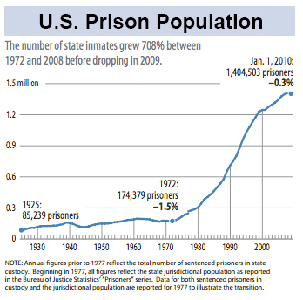
Research gathered by the ACLU (American Civil Liberties Union) from the University of Utah and the Government Accountability Office reporting on the Federal Bureau of Prisons points out that “Cost savings from privatization are not guaranteed and the quality of services is not improved. Across the board effect sizes were small, so small that the value of moving to a privately managed system is questionable”. (ACLU 20) In addition, The Economist magazine has pointed out that in Arizona specifically, the per prisoner cost to the taxpayer is actually higher when an inmate is incarcerated in a private facility (W.W).

Examples of the fallacy of privatization as a source for financial relief come from states such as Arizona, Florida, and Ohio. In each instance of the installation of private prisons, the cost increased year after year (ACLU 6). This is due to the belief that prisons can operate as free market, private entities in a capitalist society, the idea that competition would drive costs down is relative. Since these private firms have to compete with both the public prisons as well as their rivals in the private sector, the companies are encouraged by market forces to reduce costs in order to gain government contracts (JPI 6). The ACLU states that “Not only may privatization fail to save taxpayer money, but private prison companies, as for-profit institution, are strongly incentivized to cut corners and thereby maximize profits, which may come at the expense of public safety and the wellbeing of prisoners (18).

Proponents for the privatization of the prison industry have made arguments similar to those of traditional capitalists. The problem with privatizing the detainment of a citizens for profit comes is the uncertainty of how many people will become incarcerated, and if the detained population will be able to support your business. This can be explained very simply from an excerpt from CCA’s 2010 annual financial report filed with the SEC:

Our ability to secure new contracts to develop and manage correctional and detention facilities depends on many factors outside our control. Our growth is generally dependent upon our ability to obtain new contracts to develop and manage new correctional and detention facilities. This possible growth depends on a number of factors we cannot control, including crime rates and sentencing patterns in various jurisdictions and acceptance of privatization.
The document continues to state that….The demand for our facilities and services could be adversely affected by the relaxation of enforcement efforts, leniency in conviction or parole standards and sentencing practices or through the decriminalization of certain activities that are currently proscribed by our criminal laws. For instance, any changes with respect to drugs and controlled substances or illegal immigration could affect the number of persons arrested, convicted, and sentenced, thereby potentially reducing demand for correctional facilities to house them. Legislation has been proposed in numerous jurisdictions that could lower minimum sentences for some non-violent crimes and make more inmates eligible for early release based on good behavior. Also, sentencing alternatives under consideration could put some offenders on probation with electronic monitoring who would otherwise be incarcerated. Similarly, reductions in crime rates or resources dedicated to prevent and enforce crime could lead to reductions in arrests, convictions and sentences requiring incarceration at correctional facilities (ACLU 12).

The Current Prison State

One in every 100 Americans is in prison today. (Rasor 1) With less than 5 percent of the world’s population, the United States has over 25% of the world’s prison population, with more prisoners than even China. With over 2.3 million Americans behind bars, the prison population of the United States easily dwarfs that of any other country, even countries that we might think of as backwards and hostile. The New York Times quoted author Michael Tonry describing “Prison sentences here have become “vastly harsher than in any other country to which the United States would ordinarily be compared” (Liptak). The United States experienced a huge influx of prisoners after the early 70’s, representing an astounding 700% increase in the total prison population between 1970-2009 (Rasor 2).

Cause for Increase in Prison Population

“In no country is criminal justice administer with more mildness than in the United States”-Alexis de Tocqueville

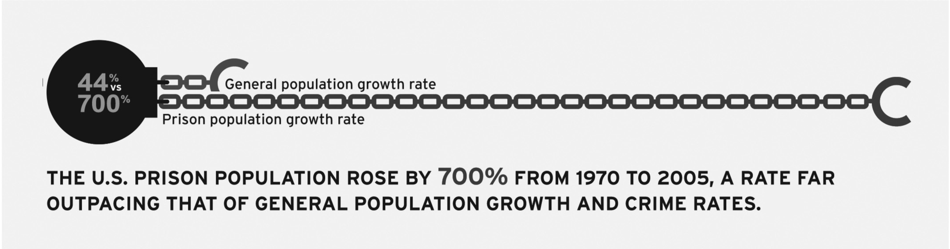
The dramatic rise in the prison population has only really occurred since the onset of the “War on Drugs” policy in the early 1970’s. This tough on crime stance that the government undertook essentially made normal, nonviolent citizens into criminals because they chose to put something in their bodies. This notion that the state was to regulate consumption of a product as a crime by an individual created the same problems that were seen during prohibition. Prior to the 1970’s, the incarceration rate had maintained a relatively stable rate of about 110 people incarcerated per 100,000 in the population (Liptak). Today’s gigantic prison population is largely made up of non violent detainees who are incarcerated on drug charges. The drug crime related population has grown in our prisons from 40,000 people in 1980, to over 500,000 today. The prison population has grown even larger owing to the fact that the average prison stay in an American prison is much more than that of European prisons, especially for drug sentences. Certain sentencing restrictions such as mandatory minimum sentences and three strikes laws play a huge role in the rise in population.

The Birth of an Industry

Before the early 1980’s private prisons were virtually nonexistent in the United States. Although we had private correctional apparatuses throughout our nation’s history, from approximately 1900, the government had kept the work of imprisonment as a public sector entity (ACLU 10). During the late 1970’s, as the drug war continued to increase the number of people incarcerated every year, states were dealing with severe budget shortfalls, and prison overcrowding was running rampant across the country, an ingenious but disastrous system was developed for dealing with the problem.

In 1983, the Corrections Corporation of America, or CCA was founded in Nashville, Tennessee by three men: Tom Beasley, the chairman of the state Republican party and was a member of the committee who chose a new state corrections officer, Doctor Crants, a Harvard MBA, and Don Hutto, the President of the American Correctional Association. These three men worked together to attempt to incite a coup within the prison structure in Tennessee (JPI 6).

In 1984 the Wackenhut Corrections Corporation was founded in Boca Raton, Florida and is known today as “The GEO Group”, after a series of mergers and acquisitions over the years. The company was granted its first correctional contract in 1987 with the formation of the Aurora ICE Processing Center in Aurora, Colorado within the Bureau of Immigration and Custody Enforcement (JPI 7)(Shahani).

“Dramatic Expansion”

The implementation of the policies that were legislated as a result of Nixon’s “War on Drugs”, and the societal mentality that was governmentally directed towards a very “tough on crime” attitude brought about a vast new wave of people being detained, and incarceration rates skyrocketed to be the largest in the world.

To understand the story of how private prisons came to be at large and as successful as they are today is to understand the methodology that corporations use to influence their way into the government. These corporations sole purpose is to make profit, directly from the taxpayers through government. CCA and GEO group have made direct relationships with politicians that are very well imbedded in the fabric of our government. These people include state and federal corrections officials, judges, as well as state, county, and federal legislatures. The system that these corporations use to gain power and more importantly contracts is comprised of 3 main ways as laid out by the Justice Policy Institute.

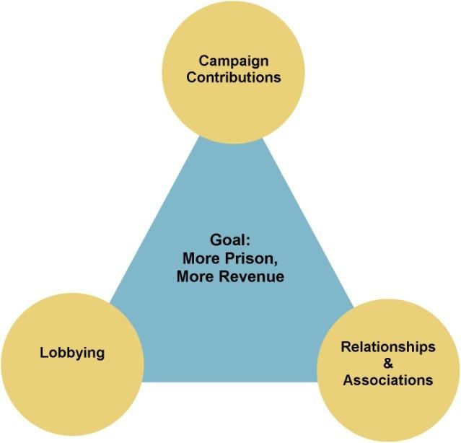
- Private prisons use relationships, networks of people, and associations to obtain government contracts. Human Resource relationships are the most intricate and vitally important strategical relationships that corporations will ever build. Numerous and astounding examples exist for just how extensively these corporations can extend their reach, even all the way up to the highest levels of the government. Here are a few examples of just how the revolving door between government and corporations is the principle source for the rampant corruption that our country faces today:
    - Joe Williams- Former Secretary of Corrections for New Mexico who in 2010 was questioned as to why GEO and CCA weren’t fined for having contract violations. Williams was previously a warden of a GEO prison (JPI 28).
    - John Kasich - Current Governor and former congressman from Ohio. Kasich worked for Lehman Brothers after he left congress in 2000 as a managing director. Before its ultimate collapse in 2008, Lehman had from 1994-2008 underwritten bonds as well as leveraged credit for CCA as well as Cornell (before it was absorbed by GEO). When Kasich won his gubernatorial campaign in 2010, he announced afterwards his intention to privatize Ohio’s prisons. Kasich’s chief of staff, and former congressional chief of staff also has a lobbying firm who represents CCA. Kasich in 200 (JPI 27).
    - Stacia A. Hylton- Federal Detention Trustee who while in office formed her own private consulting agency, and was paid by $112,500 from GEO who was her only client! While she was in office GEO was able to obtain contracts worth more than $80 million a year. Even though she did all of this, she then reentered the federal government as the head of the U.S. Marshals Service as an appointee under President Obama (Riley)(ACLU 36).
2. GEO and CCA commonly use lobbyists as a way to buy political influence in Washington DC as well as in local and state governments, most notably the American Legislative Exchange Council, or ALEC. ALEC is a lobbying group that represents CCA to write and ensure legislation that provides for much harsher sentencing and detention. ALEC’s efforts results in hundreds of bills being introduced every year, and has had over a 20% success rate with passage, which is massive when you think of the legal hurdle it is to have legislation pass directly from a lobbying group though a full legislature (ACLU 15). This is ALEC’s main purpose though; introduce the state legislators to the people who have corporate interests in mind. ALEC has over 2,000 state legislators as members who talk to corporate members who are writing “model bills” (ACLU 14).
ALEC also has introduced legislation as a model entitled “Private Correctional Facilities Act” which “This act would allow any unit of government to contract with the private sector to perform services currently performed by a corrections agency”. (Heartland). This draft legislation serves as the template for these corporations to eventually take over the entirety of the corrections structure.

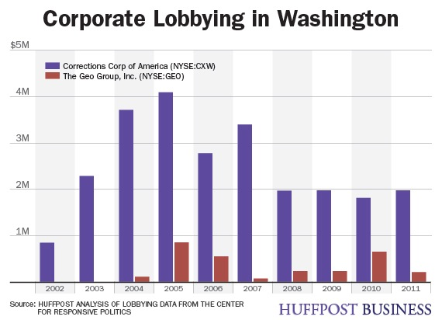
Lobbying efforts have also been the main proponent pressing for and convincing people of laws that would call for much tougher sentences for crime compared to other major industrialized countries. These efforts are tailored specifically towards the interests of companies such as CCA and GEO group. Lobbying for laws that increase the size of the prisons are essential for the prison industrial complex to guarantee profits. Prisons for profit are more than eager to lock up the more people that they can as a way to make more money. Because of these lobbies, laws such as mandatory minimum sentencing, truth in sentencing laws which stop probation and parole, and three strikes laws are all put in place by the government as a result of direct efforts from industry insiders. Mass incarceration is what makes these companies thrive, and they will do whatever it takes to make sure that their business booms (ACLU 15).

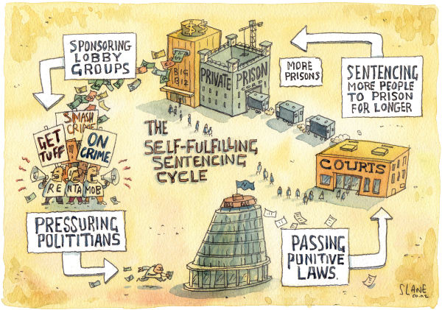
Expertly crafted and tailored legislation was written and distributed by ALEC throughout the late 1980’s and 90’s that resulted in an unbelievable growth within the prison population. Three extremely significant, and very effective strategic legislative frameworks that were constructed by ALEC have had a profound impact on the size of prison populations, the American economy, local communities, minorities, and our civil liberties (ACLU 11). Mandatory minimum sentencing for drug convictions has been an absolutely insane policy that has been implemented under the direction of ALEC. Prison sentences are determined based on the physical weight of the substance which the state has deemed illegal for our consumption. The passage of the Anti-Drug Abuse Act of 1986, marked a milestone in the federal government’s attempt to put a halt to the epidemic of crack cocaine plaguing the nation at the time. The crisis in inner city neighborhoods brought national attention, and the public was encouraged to call for legislation by the media. The bill authorized mandatory minimum sentences for possession and dealing of crack based on a weight to sentence ratio that delivered extremely harsh sentences. ALEC also crafted legislation that came to be known as “truth in sentencing” laws which in a nutshell sought to do away with parole. Proponents argued that a court shouldn’t sentence someone to x amount of years, and then release them early. The most cruel legislation they have initiated is what as known as the 3 strikes laws. If you commit a crime 3 times, you’re serving a life sentence. Three times and you’re out. The series of legislation sponsored by ALEC in states all across this country led to an absolutely dramatic rise in the prison population. According to the ACLU “Between 1970 and 2005, the number of people incarcerated in the United States grew by 700%. Today, more than 2.3 million people are presently incarcerated” ( ACLU 11).

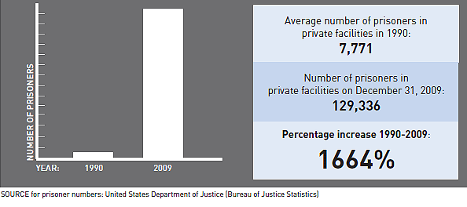
The third tier of manipulation by the prison corporations as pointed out by the Justice Policy Institute are campaign contributions. It is commonly known in our country today that lobbyists run Washington DC. Even sitting Senators and Congressmen spend a great deal of their time literally every day working to raise money for their parties as well as their own reelection campaign funds. The Supreme Court ruling of Citizens United v. FEC completely changed the game of how campaigns are financed. Our system of democracy is broken due to private interests that seek to gain and maintain control of power and force as much money as they want towards a candidate using a structure known as a PAC, which just so coincidentally ALEC has now reorganized themselves as. With no contribution limits for candidate through political action committees, the prison industrial complex has gained a foothold that they never had before. The ACLU’s research has exposed dumbfounding statistics on the growth of the for profit prison population.

The for prison population has grown at a rate that is unprecedented in this nation’s history. In 1980, literally no for profit prison institutions existed, and now today 69 for profit facilities are open, and continue to be built and utilized. Using their three pronged approach to maintaining and gaining political influence in order to guarantee their profits, the prison industrial complex has become a three billion dollar a year industry. The money that these corporations make goes to use for their own interest however, from 2002-2009 it has been reported that GEO group and CCA have spent a combined 45 million dollars on lobbying efforts and campaign contributions that are disclosed in publicly available information (Shen).

Company Specifics
Due to CCA and GEO groups lobbying efforts and political influence, the private prison industry has grown to become a three billion a year industry. Many states have been struggling to maintain a positive balance sheet during this economic crisis following the crash of 2008, and with many states becoming more and more in debt, one comes to wonder how even through these stressful economic times, for profit prison corporations have earned more money than ever before. Like a cancer that grows and metastasizes, these private endeavors are getting more traction than ever before.

CCA
In 2010 Corrections Corporation of America operated 66 private facilities, 44 of which they owned, with contracts in 19 states. CCA was able to obtain contracts with not only states but also with the federal government such as the Bureau of Prisons Immigrations and Customs Enforcement under Homeland security and the US marshals service (JPI 6). 2010 marked a record-setting year for revenue for CCA bringing in a total of 1.7 billion, $46 million more from the year previous. In 2009 the CCA housed 90,000 prisoners throughout its system of correctional facilities. CCA’s President and CEO Damon Hininger also received a compensation package worth $3,266,387 according to the ACLU (14). Half of CCA’s revenue comes from state contracts worth $838.5 million a year, and the other half comes from the Federal Government.

GEO Group
Founded in 1984 as the Wackenhut Corrections Corporation, GEO group is today’s second largest private prison corporations with over 118 facilities that house over 80,600 beds. GEO Group is distinctly different from CCA in that GEO Group is a transnational corporation operating prisons not only in the United States, but also in South Africa, the United Kingdom, and Australia. (ACLU 14) (JPI 9) According to NPR’s reporting, GEO group has grown over 10% a year for the past 10 years, and their plans for expansion are extensive (Shahani). In 2010 the GEO group had a revenue of $1.3 billion dollars, and a total prisoner population of 81,000. In 2011, GEO group’s founder, chairman, and CEO George Zoley received a compensation package worth over $5.7 million dollars (Rasor). GEO continues to grow exponentially with the purchase of a smaller prison corporations (ACLU 17).

Investors
CCA and GEO Group are both traded on the New York Stock Exchange under the ticker symbols CXW and GEO. Because these companies are profit oriented, and are ran in a way that secures their profits, big business has well as Wall Street poured money into these corporations to help them grow and to maximize profits. Numerous mutual funds and various financial institutions make significant investments into these corporations stocks. Such investment groups include Barclays, General Electric, Vanguard Group, Lazard Black Rock Investments, and Prudential Mutual Funds (Rasor 1).
The most notable and arguably the most notorious investor into private prisons is Wells Fargo. Under the TARP bail out of 2008, Wells Fargo received $37 billion from tax payers as a way to stabilize the bank during the financial meltdown. Wells Fargo used that bailout money to buy out Wachovia to become a nationwide financial power. Starting in 2009, Wells Fargo started to buy shares of GEO group. As of 2012 Wells Fargo was the second largest investor of GEO group, holding more than 4.4 million shares worth approximately $86.7 million. (Greenwald) Essentially what Wells Fargo did was take money from taxpayers to buy their way into investments that would increase their own financial success
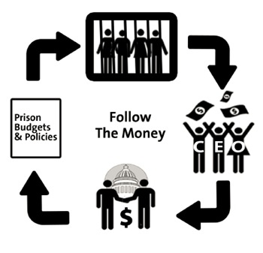
Banks are in the business of making money from investments, and the money junkies who run these financial institutions don't seem to care about the societal implications that their investments have. Like the private prison corporations, the investors are only concerned with their bottom line, and the return on their investment in the form of profit. Due to the immense power and control that the banking institutions have on government, it could very well be that banks also contribute to the policies of mass incarceration as a way to protect their own financial interest.

Immigration and Federal Detention

In 1999 CCA had loss a total of $72 million in revenue due to a lack of inmates and bad media coverage about abuses. (ACLU 17) Salon.com quotes an article from American Prospect’s article “Bailing out Private Jails” from 2001. “… with the states calling back from the trouble plagued facilities and Wall Street reacting even more strongly to the gas and scandals, big companies have found themselves over-leveraged and undercapitalized-CCA, in particular. It built new prisons “on spec,” assuming that contracts to fill them would follow, and by my estimate the company now has more than 8,500 prison beds standing empty. The firm last year came close to a financial meltdown: Its stock lost 93 percent of its value in 2000, and its accountants reported a fourth-quarter loss of more than a third of a billion dollars” (Khalek). The private prison corporations found their answer to a much needed revenue boost in immigration detention.
In 1994 the average number of immigrants being detained with 6000. In 1996, the Illegal Immigrant Reform and Immigrant Responsibility Act was passed, calling for a mandatory detention of non citizens with criminal convictions. This law like the mandatory minimum statues, was very heavily lobbied by ALEC. By 2001, the number of detained illegal aliens had risen by over 300% to 20,000. (ACLU).
While the relationship might not be clearly evident at first glance, the impact of the attacks on September 11, 2001 had a notable impact on the size of the detained immigrant population. The ACLU cites a report submitted to the U.N. Special Rapporteur on the Rights of Migrants recalling what the CEO of Cornell Corrections (which was later acquired by GEO group) Steve Logan, stated just two months after 9/11. “It is clear that since September 11 there’s been a heightened focus on detention. More people are going to get caught. So I would say that’s positive. The federal business is the best business for us, and September 11 is increasing that business” (ACLU 16-17).
Although Logan’s statement is deplorable in that he is profiteering off of the worst terrorist attack in modern history in this country, he was accurate in assessing that the size of the incarcerated immigrant population would grow. By 2010, the size of the detained immigrant population grew by 50% from 2001 levels to 31,020, and a massive increase of 457% increase from the 1994 level (ACLU 18). Following the terrorist attacks on 9/11, the Department of Homeland Security was created, which had the responsibility of overseeing ICE (Khalek). Due to increased targeting of immigrants under this federal structure, the number of aliens being detained swelled to over 390,000 a year. At any one time 33,330 immigrants are detained under the directive of the Department of Homeland Security (Lee).
The Wall Street Journal has reported that in 2011, 32% of all federal criminal convictions were immigration cases, and that congress has required ICE to keep 34,000 beds occupied at all times. Federal contracts, including those with ICE are incredibly lucrative and profitable for both CCA and GEO group. CCA in 2012 had $206 million dollars in ICE contracts, and GEO group receives over 40% of its $1.4 billion revenue directly from federal contracts. With potential immigration reform looming, it is estimated that 14,000 more illegal immigrants will be detained, and an estimated 80% of those would be detained in a private prison (O’Connor).
GEO group is no novice to the detention and enforcement of immigration laws. The New York Times refers to the actions of GEO group in Australia and South Africa as the “detention-industrial complex” (Bernstein). In Australia, the government has transferred literally all enforcement of immigration policies to the private sector with horrifying consequences. Stories of malfeasance and abuse in what are essentially prison camps for immigrants has caused for a serious dialogue to develop in Australia which is still ongoing due to their huge influx of immigrants from South East Asia. In Australia alone, their central government has already signed contracts worth over $10 billion (USD) with multiple private prison corporations.
The Federal Bureau of Prisons signed 13 contracts with both CCA and GEO in 2012 worth over $5.1 billion to house criminal immigrants (Shen). These contracts also include services for the U.S. Marshal’s service which in 2010 accounted for 19% of GEO’s revenue. As described previously, Stacia Hylton, the now head of the Marshal’s service as appointed under Obama has been paid tremendous sums by GEO group, and is still doing her part to ensure that her kickbacks keep on coming (Rasor).
Numerous prominent federal officials have gone through the revolving door from federal corrections into the prison industrial complex. These individuals include:
  - John M Hurley- Senior VP for GEO. Served 26 years in the Federal Bureau of Prisons, and is now earning a salary of $1.5 million.
  - Norman Carlson- Board of Directors member for GEO group. Served 17 years in the Federal Bureau of Prisons who collects a federal pension, as well as a $800,000 a year salary from GEO.
  - Donna M. Alvardo- CCA Board member. Former Deputy Assistant to the US Secretary of Defense as well as serving counsel of the US Senate Judiciary Committee on Immigation and Rufugee Policy, as well as a member of the US House of Representatives Select Committee on Narcotics.
  - Dennis Deconcini- CCA Board member and former US Senator from Arizona
  - Thurgood Marshall Junior- CCA Board member. Son of Supreme Court Justice Thurgood Marshall, as well as former cabinet secretary to President Clinton as well as director of legislative affairs and deputy counsel for former vice president Al Gore. Marshall also is a partner of Bingham McCutchen, a DC law firm that is involved with lobbying.
  - Harley G. Lappin- Chief Corrections Officer for CCA. Former director for the Federal Bureau of Prisons. Resigned from BOP after an untimely DUI incident.
  - J. Michael Quinlan- Senior VP CCA, former Director of the Bureau of Prisons where he left after a sexual misconduct allegation. (Rasor)
The influence that CCA and GEO have amassed from these individuals is almost incomprehensible. The promise of money and influence to these individuals is certainly enticing, and the role that they play to the continuation of this industry is invaluable.
Guaranteed Profits
Although CCA and GEO Group have been able to dramatically increase their profit margin from the detention of illegal immigrants, these companies still have sought to increase their political and financial influence through traditional corrections services for the US civilian population. For profit prisons that are dependent on an ever-growing population of prisoners have developed a unique strategy to have the states where there prisons are located do the dirty work for them. They do this through a series of contractual agreements that call for occupancy quotas. This is also known as a low crime tax. Guaranteed occupancy clauses are present in 65% of private prison contracts (In the Public Interest 2). Private prison corporations construct these contracts in such a way that they have a guaranteed prison population to protect their profits to reduce their financial risk. High occupancy rates are critical to the success of these businesses (ITPI 5). These corporations contractually bind states to keep their private prison facilities at anywhere from 80 to 100% occupancy. The majority of such contracts are around 90%.
Arizona has by far the worst contractual agreement policy in the nation. GEO owns three prisons in Arizona that require 100% occupancy. These agreements were sold by GEO as a way to guarantee that costs would not rise in the price for incarceration, however, In the Public Interest has cited a report from the Tucson Citizen that shows that even with these policies, the daily rate for inmates has increased by 13.9% (8).
In states such as Colorado where the crime rate has gone down by over a thirds since 2009, the taxpayer is stuck with the bill for empty beds inside of these private prisons due to these low crime taxes. Coloradans are paying an estimated two million a year for empty beds within these prisons, and the rate of incarceration continues to fall (ITPI 8).
Although guaranteed contracts are extremely beneficial for the private prison companies and the banks and hedge funds that on them, these policies are incredibly destructive for state finances, as well as citizens civil rights. Guaranteed occupancy not only provides the state with an incentive to incarcerate you as a way to maintain their contractual agreements, it also turns the average citizen into a money machine for the state. The goal of government should be to reduce crime and to provide for real and inventorying rehabilitation. Because of these contractual obligations, the prison industrial complex now has a revenue stream with almost no risk to profit. These companies survive off of tax payers’ money, while incarcerating said tax payers.

Additional Profit and Slave Labor
In the era of reconstruction following the Civil War, A substitute for slavery came into being. This enterprise known as the convict the system allowed State and local governments to manage prisoners but would lease them out to work for private companies. Prisoners were treated horribly under these conditions, seeing as the lessor had zero interest in the health or wellbeing of their hired slaves (ACLU 10).
Thirty-seven states have legalized the same leasing of prisoners that was common during reconstruction in today's America. The incarcerated population provides a perfect workforce for corporations that wish to have American-made products at Third World prices. Corporations that contract prisons in the United States are among some of the largest in the world. These companies include Hewlett-Packard, Motorola, Microsoft, AT&T, TWA, Target, Boeing, Intel, as well as many others (Pelaez).
Investigative reporter Vicky Pelaez’s research into the federal prison industry uncovered that, “100% of all military helmets, ammunition belts, bulletproof vests, ID tags, shirts, pants, tents, bags, and canteens are all produced by federal inmates. Along with war supplies, prison works supply 98% of the entire market for equipment assembly services; 93% of paints and paintbrushes; 92% of stove assembly; 46% of body armor; 36% of home appliances; 30% of headphones/microphones/ and speakers; and 21% of office furniture. Airplane parts, medical supplies, and much more; Prisoners are even raising seeing eye dogs for the blind” (Pelaez).
In public prisons, inmates that work are paid the minimum wage under law, however inmates in private, for profit prisons are paid as little as 17 cents an hour for their labor, which works out to about $20 a month. The highest paying private prison in the country is a CCA prison in Tennessee that pays 50 cents an hour for skilled production workers (Snyder). Now that we have the largest prisoner population in any civilization in world history, the powers that control this industry obviously are going to exploit the potential of all of these inmates for further profit, and as a marketing scheme to sell to the American people “Made in the USA” products. Oregon State Rep. Kevin Mannix actually urged Nike to bring its production from Indonesia to his state because the prison population would be more competitive.
These corporations have gone so far to protect their profits that they will understaff their facilities, maximize prisoner capacity, and charge prisoners five dollars a minute to make phone calls (Bradford), or charge family members $25 to see their relatives in prison (Goode).
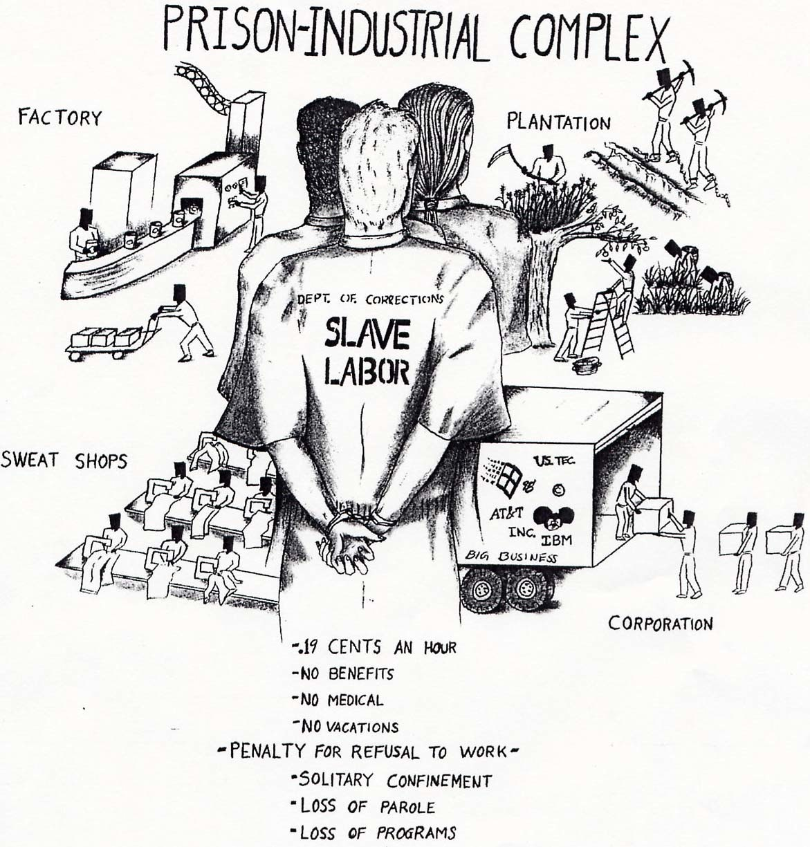
Ramifications of the Prison Industrial Complex
The idea of incarceration for profit is hugely dependent on making citizens into criminals for the purpose of making money. Innocent people that have committed no crime against anyone else, but chose to put a substance in their own bodies become part of this machine that has been constructed to make money while enslaving them. With the largest prison population in the world developing in our nation over the last 30-40 years, we as Americans have become conditioned to think that certain actions of individuals are illegal and require hard time.
Knowing that these prison corporations that are owned by the big banks that we as taxpayers bailed out during the financial crisis of 2008 are now turning around and using that money against us to lobby for more laws and regulations are put in place to make sure that more people go to jail is to know that the entire criminal justice system has now been stacked against the average citizen. Add on top of that the fact that the police are incentivized and required to meet quotas on certain criteria to advance in their careers, and that attorneys and courts and judges and these prisons are all dependent on the free people to break their rules that they have manipulated into existence as a way to further increase revenue and to justify their positions. Our civil liberties have gone down the drain at the expense of big business and greed.
Mussolini is quoted as saying: "Fascism should more properly be called corporatism because it is the merger of state and corporate power.” What else could we call corporations like CCA and GEO besides fascistic? While the term is thrown around without much meaning on a regular basis, this truly is fascia.
When States merge with these corporate interests, and the politicians themselves are receiving money from the same interests that are dependent on people being incarcerated for their profit. These corporations take the taxpayers money and use it against them to lobby for harsher sentences and for a continuation of this prison state that we are now living in by buying off any politician or official within the government that can be compromised. This system of guaranteeing that prisons will be a certain percentage full is one in which the citizens are the victims of the state for their own financial interests. No more are governments interested in reducing crime! In fact, they are looking for more reasons to lock people up. It’s good for business, and it is a business that is booming.
Abuse and Corruption
There are many consequences that could happen with private own prisons. With this type of system in place abuse and corruption could become out of control. As in the Stanford Prison Experiment of 1971.Where twenty-four students acted as guards and prisoners in a fake prison study. The guards started to abuse the prisoners mentally and physically. They stripped them of all their clothes and started to harass them. The experiment ended abruptly after six days because it was no longer just an experiment it was becoming dangerous. Now think this was just an experiment. Just think of what could happen in these private prisons. And there is nothing the states with these prisons can do about it. They no longer own the prison. They just have to keep it filled to capacity.
There is also no control for the states in anything about the prisons not even the guards that watch over the prisoners. The CCA hires the people so they could be under qualified for the job and no one would ever know. This could lead to the abuse because they aren't properly trained. David Zucchino from the Los Angeles Times states, “The American Civil Liberties Union has released government documents containing 185 allegations of sexual abuse against female immigration detainees in federal detention centers since 2007” (Zucchino). Most of these abuses the article talks about are in Texas. Some are even from the facility in Taylor, Texas, which is run by the CCA. The facility in Taylor, Texas is the known as the T. Don Hutto Residential Center. It is for detaining non-US citizens that are waiting to immigrate into the United States. One abuse story is a girl named Kimberly. She was fleeing to America because her husband was threatening to kill her. She was granted asylum and when she was on her way to the airport is when the abuse began. The guard driving her pulled to the side of the road and started to touch her inappropriately. “I was in a situation that I never dreamed I would be in. I was already running away from one person. I was afraid, afraid for my life, wanting to get out of there”, explains Kimberly (Sexual Abuse in Immigration Detention - Kimberly's Story). This is just one story, while there are many more out there that have yet to be discovered. The CCA has no control of what is going on. They just let the abuse continue.
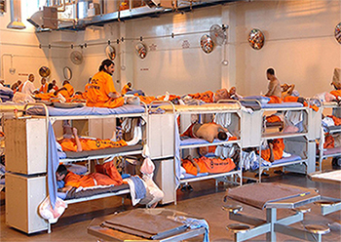
Along with the sexual abuse comes the poor sanitation. In 2011, the CCA bought Lake Erie Correctional Institution from the state of Ohio. Within one year of the CCA owning this facility failed two state audit inspections. Both of these inspections came back with abuse and unfathomable conditions that the state would never allow. The prison is between a ninety to ninety-five percent occupancy statuses through their contract with the CCA. Aviva Shen, a writer for Think Progress, says, “The Lake Erie prison is now reportedly overcrowded at 130 percent capacity, with single-person cells holding 3 inmates each, according to internal documents obtained by the ACLU”(Shen). Having this many prisoners in a room leads to the inmates sleeping on the ground where they might not even have mattresses. And the rest crammed into a one person bed. By doing this the private prison companies are able to keep more money for themselves. Sanitation, staff, and space are only good to the bare minimum. Even then they are not good for the inmates or the guards inside these facilities. Having the worst possible conditions makes for bad situations to occur at the prisons. Riots and disturbances are increasing in the private prisons. Lake Erie is seeing this problem as well. “Assaults on guards and other inmates have skyrocketed by 40 percent” (Shen).
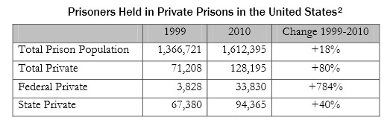
The increase of inmates is overwhelming the staff of these facilities. It makes it harder to control the situations if the guards are severely outnumbered. If there are more prisoners than guards and staff it is harder to know where everyone is at one time. This makes it easier for drugs and other materials to be brought or smuggled into the prison. The poor sanitation and the increase of inmates is a significant problem with these privately owned prisons. And all of this is just so the corporations can save as much money as possible.
The corruption behind these prisons is written in their contracts. They make it so law enforcers can send more people to prison. This should be the other way around. Prisons should want less people going into prisons. This would decrease crime in that city but the corporations want more people in prison for more money.
They make corrupt contracts that give them an advantage over everyone else. Even certain companies campaign for stricter punishments. That way people spend more time in their prisons. David Harris-Gershon, from Tikkun Daily, asserted, “America has the highest rate of imprisonment in the world. And the private prison industry is a central driving force behind this”(Harris-Gershon). As the CCA pushes for my states to have private prisons more people are going to be imprisoned. Soon enough something like running a red light might put someone behind bars for months. The laws will become stricter and we will have to open even more prisons to hold all of these new prisoners. But that is just what the private prison companies want. The more prisons these companies control means more pools of money they have to swim in.

Conclusion:
In conclusion the government pays out millions of dollars a year to companies like the CCA (Corrections Corporations of America). Hundreds of millions of dollars go to the CCA in agreement that they will, “by protecting public safety, employing the best people in solid careers, and rehabilitating inmates” (CCA website). They promote this with such a positive statement it is hard to see the corruption that lies beneath.
We saw in the Prison-Stanford experiment the different psychological pressures came with being a prison and a prison guard. As the study mentions it was cut early because of the severity of the different actions and the ability to foresee something getting out of hand very quickly. What’s not to say this experiment happens in real life and doesn’t happen every day in the CCA facilities? When a state contracts with private prison companies to operate these facilities, it hands over the control of the public’s goals and priorities and can choose to ignore them.
The CCA is a corporation and a business. Unlike regular State facilities the CCA holds quotes they force state regulators to abide by, in the contracts they sign with these state regulators. These quotes must be met. Whether there is an inmate staying in a bunk, the government and ultimately tax payer pay whether or not these beds are occupied or not.

Suggestions to problem:
Having bed quotes for prisons isn’t just morally wrong it’s bad for society as a whole. Having these bed quotas forces government officials to pass laws and ultimately look harder for people violating laws to throw them in prison or pass laws increasing the duration of time spent in jails and prison for minor offenses. New Orleans District Attorney Keva Landrum-Johnson was wanting to seek five-20 years sentences for minor pot possession offenders (Armentano 1).
Figure 1- Prisoner locked up
Throwing people in prisons not only diminishes the idea of constitutional American and the right to a fair sentence, but it shows the American system is corrupt. Throwing someone in prison for more than a decade is not justice. As mentioned in the conclusion the Corrections Corporation of America is a business, and therefore they’re in business to make money. To maximize profit the CCA demands to have these prisons full all the time, meaning they would have to train and educate prison guards, unfortunately this can and does leave companies like the CCA at increase of higher incidences of violence due to the lack of guard training due to the wanting of maximizing profits.
“Private prison companies often attempt to lure the government into agreements with bed guarantee clauses by promising a lowering the cost per prisoner” (PublicInterest 11). These bed guarantees usually come after the contract has been signed between the government and the CCA ultimately, allowing the CCA to pick a quota without question. The government signs itself up to spend public dollars on housing and the supervision of inmates whether the prison is full or not! It makes no sense to fund these private companies, one why should we have to pay a company to watch empty and two with massive budget cuts, the government doesn’t need to pay people to stand around watching these empty beds.
The federal government doesn’t need to work with these private corporations they can reject these companies and go with public operated jails controlled by the state or work with private corporations with no quotas. “There are a number of private prison contracts without bed guaranteed clauses” (PublicInterest 11). In order for these private companies like the CCA to gain these contracts these prison operators bid on the different contracts the “Lowest” bidder wins that contract. The government chooses to agree to these terms placed down by these private corporations. “State legislators can negotiate reasonable per diem rates without resorting to bed guarantees” (PublicInterest 11).
Figure 4- President Obama speaking to Congress.
“Elimination of bed guarantee clauses will allow lawmakers to enact politics that are in the public interest, not in private prison cooperation’s financial interest” (PublicInterest12). The elimination of these quotas would focus criminal justice policies to focus more on public goals of decreased crime rates and empty prison cells. It’s the government’s obligation to make the best decisions in the public’s interest.

Works Cited

The American Civil Liberties Union. “Banking on Bondage: Private Prisons and Mass Incarceration.” Text. New York, New York, 2011

ACLU. “Sexual Abuse in Immigration Detention.” Website. October 19, 2013

ACLU. “Sexual Abuse in Immigration Detention” – Kimberly's Story. Website. October 19, 2013
Armentano, Paul. "20 Years For Pot Possession." Website. July 24, 2008. Article. October 10, 2013.

Bernstein, Nina. “Companies Use Immigration Crackdown to Turn a Profit.” The New York Times, September 28, 2011.

Bradford, Harry. “Inmates in Private Georgia Prison Charged Five Dollars Per Minute For Phone Calls”. The Huffington Post, November 18, 2011

Burnett, John. “Town Relies On Troubled Youth Prison for Profits.” National Public Radio. March 25, 2011.

CBS News, “Obamacare Website Security Tests Never Finished Before Launch”. Website
November 5, 2013

CCA. “Economic Development and Community Outreach with CCA.” Website. 20 Oct. 2013
.
Fact Sheet: “T. Don Hutto Residential Center.” Website. 19 Oct. 2013

FindLaw. “Private Jails in the United State”. Website. October 20, 2013

Goode, Erica. “Inmate Visits Now Carry Added Costs in Arizona” The New York Times, September 4, 2011.

Greenwald, Glenn. “Wells Fargo Prison Cash Cow.” April 11, 2012

Grassroots Leadership. Corrections Corporation of America. “A Critical Look at its First Twenty years” Oct 12, 2013

Harris-Gershon, David. America's Corrupt Justice System: Federal Private Prison Populations Grew by 784% in 10 Year Span. Website. October 20, 2013

Heartland Institute, “Private Correctional Facilities Act.” Website. November 2, 2013

In the Public Interest. Criminal: How Lockup Quotas and “Low-Crime Taxes
Guarantee Profits for Private Prison Corporations” Washington, DC, 2013

Justice Policy Institute. “Gaming the System: How the Political Strategies of Private
Prison Companies Promote Ineffective Incarceration Policies.” Washington,
December 2011.

Khalke, Rania. “How the Private Prisons Game the System” salon.com online, December 1, 2011.

Lee, Suevon. “By the Numbers: The U.S.’s Growing For Profit Detention Industry.”
ProPublica, online. June 20, 2013

Liptak, Adam. “US Prison Population Dwarfs that of Other Nations.” The New York Times, New York, New York, April 23, 2008.

O’Connor, Patrick. “Private Prisons Are Likely to Benefit From Rewrite of Immigration Laws.” The Wall Street Journal, July 5, 2013

Pelaez, Vicky. “The Prison Industry in the United States: Big Business or a New Form of Slavery?” Global Research, online, January 31, 2013

Rasor, Diana. “America’s Top Prison Corporation: A Study in Predatory Capitalism and Cronyism.” Website. May 3, 2012

Rasor, Diana. “Prison Industries: Don’t Let Society Improve or We Lose Business”.
truthout.org, online. April 26, 2013

Ridgeway, James. “Ex-Con Shareholder Goes After World’s Biggest Prison Corporation.” Mother Jones Online, May 12, 2012

Riley, Ryan J. “Senate Confirms U.S. Marshals Director with Private Prison Ties.” Talking Points Memo, online. December 24, 2010.

Shahani, Aarti. “What is GEO Group?” National Public Radio, March 5, 2011

Shen, Aviva. “Over 18 Months, Nation's First Privately Owned State Prison Has Declined Rapidly.” Website. October 20, 2013

Shen, Aviva. “Private Prisons Spend $45 Million On Lobbying, Rake In $5.1 Billion For Immigrant Detention Alone.” Website.

Snyder, Michael. “Private Prisons: The More Americans They Put Behind Bars The More Money They Make”. Website. March 11, 2013

Stroud, Matt. “Why Would a Prison Corporation Restructure As a Real Estate Company?” Forbes Magazine Online, January 31, 2013

W.W. “The Perverse Incentives of Private Prisons.” Website , August 24, 2010

Zimbardo, Philip G. “Stanford Prison Experiment.” Website. October 12, 2013

Zucchino, David. “ACLU releases documents alleging sexual abuse of female detainees.” Website. October 19, 2013

Photo Index
All figures retrieved from Google image

